Note: The term “enterprise” is used throughout and interchangeably to refer to “business” or “company”.

ELIGIBILITY CRITERIA

- GENERAL REQUIREMENTS

- Registered/Incorporated with Registry of Companies and Business Names (ROCBN).
- Any private enterprise with any form of Government shareholding is not eligible.
- Enterprises with a minimum of 50% in local ownership.
- Operational for a minimum of 3 years.
- Financial statements must be available for at least 3 years:
  - Management Accounts for:
    - Sole Proprietorship
    - Partnership
    - Private Limited Company (Sdn Bhd) with revenue below BND 1 Million
  - Audited Financial Statement for:
    - Private Limited Company (Sdn Bhd) with revenue below BND 1 Million (if available)
    - Private Limited Company (Sdn Bhd) with revenue above BND 1 Million
- AWARD–SPECIFIC ELIGIBILITY

OPEN AWARD CATEGORIES
Open to enterprises from all industries across Brunei, provided they meet the general and local value content requirements stated above.

- Business Growth: Recognises enterprises that have achieved significant expansion through revenue growth, wider market reach, job creation, and strategic leadership.

- Innovation: Honours enterprises that drive progress by delivering innovative solutions, enhancing customer experiences, or transforming internal processes through creative, forward-thinking approaches.

- Startup: Celebrates high-potential startups with scalable business models that have successfully disrupted markets and achieved rapid growth through bold, innovative strategies.
  - Open to startups operating for less than 5 years in any industry in Brunei.
- Youth Entrepreneur: Recognises outstanding youth entrepreneurs who demonstrate exceptional leadership, resilience, and impactful entrepreneurial achievements.
  - Applicant must be aged 18 to 35 years old.
  - Must hold the status of Bruneian Citizen or Permanent Resident.
  - Applicant must be a registered entrepreneur with ROCBN and actively involved in their business operations for at least the past 3 years, fulfilling one of the following roles: i) Founded and established their own enterprise; and/or ii) Shareholder with a significant majority ownership stake.
  - Applicant must demonstrate exceptional success through leadership and achieved significant entrepreneurial milestones.
- Women Entrepreneur: Honours exceptional women entrepreneurs who have achieved notable entrepreneurial success and demonstrated influential, innovative leadership in their fields.
  - Applicant must be female.
  - Must hold the status of Bruneian Citizen or Permanent Resident.
  - Applicant must be a registered entrepreneur with ROCBN and actively involved in their business operations for at least the past 3 years, fulfilling one of the following roles: i) Founded and established their own enterprise; and/or ii) Shareholder with a significant majority ownership stake.
  - Applicant must demonstrate exceptional success through leadership and achieved significant entrepreneurial milestones.

PRIORITY CLUSTER CATEGORIES
Open to enterprises within the 5 Priority Clusters, outlined in the Economic Blueprint for Brunei Darussalam, provided they meet the general and local value content requirements stated above.

- Food: This category extends beyond traditional food outlets to include enterprises that strengthen Brunei’s food supply chain through innovation, sustainability, and economic contribution. Applicable enterprises include, but not limited to:
  - Primary production: crop and animal production, fishery and aquaculture.
  - Food processing and Manufacturing: meat, seafood, fruit, vegetables, dairy, animal feed, etc.
  - Beverage Manufacturing: soft drinks, mineral and bottled waters, others.

- Tourism: Recognises local enterprises that have made significant contributions to the tourism sector by promoting Brunei’s cultural heritage, natural beauty, and unique visitor experiences, while demonstrating innovation, excellence, and sustainable practices. Applicable enterprises include, but not limited to:
  - Food & Beverage Services: Restaurants, cafes, or culinary experiences showcasing authentic Bruneian cuisine.
  - Tour/Travel Agents: Enterprises that design and manage memorable travel experiences e.g. adventure, nature, cultural, community-based activities, or local product experiences.
  - Accommodation services: Hotels, short-term accommodation and others delivering exceptional service and hospitality.
  - Wellness: Spas and wellness centres offering relaxation and therapeutic experiences.
  - Land, water and air transportation promoting local tourism.

- Downstream Oil & Gas: Recognises enterprises that drive the growth of Brunei's downstream oil and gas sector through strong performance, innovation, operational excellence, and sustainable practices. Applicable enterprises include, but not limited to:
  - Value-added Petrochemical Production
  - Refining and Processing Operations: Enterprises upgrading oil and gas outputs.
  - Industrial Services and Support for Oil & Gas: Enterprises providing engineering, maintenance, inspection, logistics, and technical service providers.
  - Manufacturing & Fabrication: Enterprises producing equipment, components, or materials for downstream operations.
  - Environmental & Sustainability Services: Enterprises offering renewable energy solutions that enhance efficiency or support environmental compliance.

Applicants for Downstream Oil & Gas (Priority Cluster Category) have the additional requirement to meet employment ratio requirements as per Directive 2: Local Business Development (LBD) Framework for the Oil & Gas Industry (additional guidelines can be found here).

- ICT: Celebrates excellence in digital solutions, fintech and e-commerce, recognising enterprises that demonstrate innovation, sustainability, and meaningful contributions to Brunei's socio-economic progress. Applicable enterprises include, but not limited to:
  - Content and media production: publishing, motion picture, video, sound, broadcasting etc.
  - Digital solutions providers: Enterprises developing or deploying advanced technologies-such as AI, drone tech, data tech, and startups-to boost efficiency and drive innovation across industries.
  - Fintech: Enterprises offering digital financial products and services that enhance financial access and modernize Brunei's financial ecosystem.
  - E-commerce: Enterprises expanding digital commerce through seamless online platforms that empower enterprises, improve consumer access, and strengthen Brunei's digital economy.

- Services: Recognises enterprises that demonstrate outstanding performance and innovation in Brunei's services sectors, contributing meaningfully to economic diversification and industry growth. Applicable enterprises include, but not limited to:
  - Professional and Support Services: Logistics services, trading, administration, IT and technical support, audit and finance, marketing, web development, HR and people management, legal services, construction, architectural and other related services.

SUBMISSION GUIDELINES

Document Checklist
Kindly prepare the applicable documents listed below to attach to your application:
 | Yes | No | N/A
Copy of Business Registration (16/17 or Form X) or Company Certification of Incorporation | ☐ | ☐ | ☐
Latest filing of Annual Returns and Income Tax Returns  (for private limited companies only) | ☐ | ☐ | ☐
Identification Card (for shareholder(s)/owner(s) only) | ☐ | ☐ | ☐
Shareholder certificate(s) (for private limited companies only) | ☐ | ☐ | ☐
High resolution enterprise logo | ☐ | ☐ | ☐
Audited financial statement for the past 3 years  (for private limited companies with revenue above BND1million) | ☐ | ☐ | ☐
Management accounts for the past 3 years  (for sole proprietorship, partnership or private limited companies with revenue below BND1million) | ☐ | ☐ | ☐
Track record, including key projects or portfolio, for at least the past 3 years | ☐ | ☐ | ☐
Any media coverage or documents highlighting external recognition (if applicable) | ☐ | ☐ | ☐
Certificates and/or Standards (if applicable) | ☐ | ☐ | ☐

Submission Guidelines
- Please submit your completed application form with supporting documents to proudly.brunei@bedb.gov.bn no later than Monday, 2nd February 2026, at 11.59 PM.
- All documents are to be submitted in either PDF, DOC, DOCX, PNG, JPG, JPEG & GIF files.

Disclaimer
- All information provided will be treated with the utmost confidentiality and used solely for evaluation purposes.
- Incomplete applications will not be entertained.
- As part of the validation process, on-site visits, interviews and/or reference checks may be employed, whereby reference person(s) listed at the end of the application form may be contacted.

AWARD CATEGORIES

Kindly tick which award category you would like to apply for. Each enterprise is entitled to a maximum of 2 award categories.

OPEN AWARD | PRIORITY CLUSTER
☐ Business Growth  ☐ Innovation  ☐ Youth Entrepreneur  ☐ Women Entrepreneur  ☐ Startup | ☐ Food  ☐ Services  ☐ Tourism  ☐ ICT  ☐ Downstream Oil & Gas

APPLICATION FORM

Please complete ALL applicable sections based on the award categories you are applying for.

Sections marked with an asterisk (*) are only required for specific categories.

APPLICANT INFORMATION
*only applicable for YOUTH and WOMEN Entrepreneur Award

Full Name
Date of Birth
Gender
Position/Title
in the enterprise
Contact Number
Email Address
No. of years involved  in the operations of the enterprise | ☐ Less than 3 years | ☐ 3 – 5 years | ☐ More than 5 years

ENTERPRISE OVERVIEW

Applicant’s Enterprise Profile

Enterprise Name
Registration/
Incorporation No.
Registration/
Incorporation Date
(dd/mm/yyyy)
Type of Entity | ☐ Sole Proprietorship | ☐ Partnership | ☐ Private Limited (Sdn Bhd)
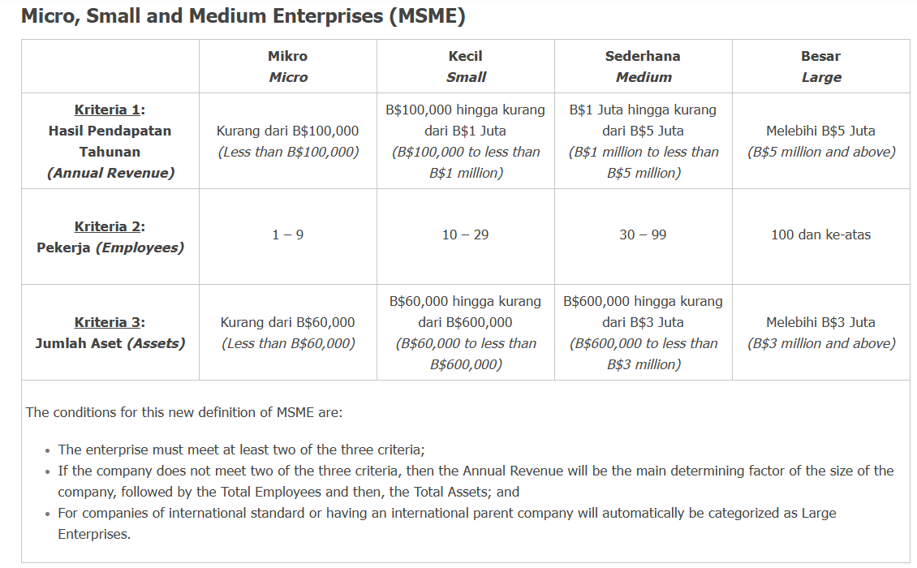
Enterprise Size (Please see above definition) | ☐ Micro | ☐ Small | ☐ Medium
Enterprise Size (Please see above definition) | ☐ Large
Industry Classification (include Industry Code & Name according to BDSIC, e.g. 5611 Restaurants)
Details of Owner(s), Shareholder(s) and/or  Director(s)  as stated in Business Registration | Full Name(s) | Nationality | Share (%) | IC No.
Contact Information | Enterprise Address
Contact Information | Website
Contact Information | Social media
Focal Person Details | Position/Title
Focal Person Details | Contact Number
Focal Person Details | Email Address

About your Enterprise

Briefly describe your main activities (enterprise concept, product/services and its target market)
What is your enterprise vision and mission?

ENTERPRISE GROWTH

Financial Performance
To understand the financial health of your enterprise better, please provide details of your financial performance for the past three years, based on your financial year accounting period, starting from 2023.

Performance Indicator | 2023 | 2024 | 2025
Annual Revenue
Annual Net Profit

Other Performance Indicators

No. of new branches/ subsidiaries established in Brunei or overseas over the last 3 years (and more, if applicable)
List down any notable achievements or milestones your enterprise has reached within your industry over the last 3 years (and more, if applicable) (e.g. awards, recognition, growth, impact on the economy and community)
(200 words)

Future Expansion Plans

Demonstrate your future expansion plans in the next 5 years (e.g. new branches, subsidiaries, joint ventures, partnerships, product distribution)
(400 words)

Sustainability

How do you incorporate market changes, competition and evolving customer needs into your 5-year strategy to ensure sustainable growth for your enterprise?
(200 words)
Demonstrate any Corporate Social Responsibility activities from your enterprise (environmental responsibility, social impact and ethical practices)
(200 words)

LOCAL VALUE CONTENT

No. of employees | 2022 | Local: | Foreign:
No. of employees | 2023 | Local: | Foreign:
No. of employees | 2024 | Local: | Foreign:
Product/services designed locally  Not applicable for Downstream Oil & Gas Award Category | ☐ Yes  ☐ No
Product produced locally  Not applicable for Downstream Oil & Gas Award Category | ☐ Yes  ☐ No
Place of manufacture
Does your product/service currently (or have the potential to) support import substitution efforts? | ☐ Yes  ☐ No
Brief description of how your enterprise incorporates and promotes Bruneian cultural elements, values and/or traditions
(200 words)
Not applicable for Downstream Oil & Gas Award Category

INNOVATION
*applicable to ALL categories EXCEPT Business Growth Award

Innovative Distinction

How does your enterprise or product/ service differ from your competitors, especially in terms of innovation?
(200 words)
In what ways has this innovation positively influenced your enterprise’s revenue and market reach?
(200 words)

Innovation Culture

How does your enterprise actively encourage, promote and foster generation of new ideas in its operations?
(200 words)

EMPLOYMENT
*applicable to ALL categories EXCEPT Business Growth and Innovation Award

Work Environment

What initiatives has your enterprise adopted to foster a positive workplace culture? (e.g. open communication channels, recognition programmes, wellness initiatives)
(200 words)

Professional Growth & Career Development

How does your enterprise prioritise and facilitate employee development to ensure continuous skills enhancement and career growth? (e.g. assessment, training & development, knowledge transfer)
(200 words)

LEADERSHIP
*only applicable for YOUTH and WOMEN Entrepreneur Award

Adaptability & Resilience

Describe how your leadership has contributed to the growth and success of your enterprise
(300 words)

ADDITIONAL INFORMATION

Tell us why your enterprise should win the award(s)
(200 words)
For Women or Youth Entrepreneur Award applicants, tell us why you should win the award(s)
(200 words)

REFERENCE

Please provide the names and contact details of up to two (2) referees who can speak to your qualifications, achievements, and character, and ensure you have obtained their consent beforehand. At least one (1) referee must be a current colleague and/or employer, and none may be affiliated with the Brunei Economic Development Board in any capacity.
Reference 1:

Name of referee
Relationship to applicant
Contact number
Email address

Reference 2:

Name of referee
Relationship to applicant
Contact number
Email address

STATUTORY DECLARATION

By submitting this application form, I affirm that all provided information is accurate and has been approved by a Member of the Board of Directors or an equivalent authority within the company/business and hereby solemnly declare as follows:
- I declare that the statements made herein are true and correct to the best of my knowledge, information, and belief.
- I declare that the company/business does not have any criminal records and is not subjected to any bankruptcy and/or winding up proceedings.
- I undertake that the company/business is under an obligation not to be involved in any legal disputes within one year after receiving the Proudly Brunei Business Awards.
(collectively referred to as “obligations”)
- Failure to adhere to the aforementioned obligations may result in Brunei Economic Development Board exercising its right to revoke the Proudly Brunei Business Award. This revocation shall necessitate the prompt return of any monetary prize and physical award/trophy received, as well as immediate termination of any strategic collaboration with the identified strategic organization.
- I further understand and agree that the awarded company/business is responsible for ensuring its compliance with the aforementioned obligations for a one-year duration of the marketing campaign associated with the Proudly Brunei Business Award. Compliance with these obligations is essential for upholding the integrity of the awarded recognition.
- I acknowledge that I have been made aware of the aforementioned obligations, and I undertake to adhere to them accordingly.

Declared by:

Full name (as stated in IC)
Position
Company/Business Name
Signature

